1.Installed windows 11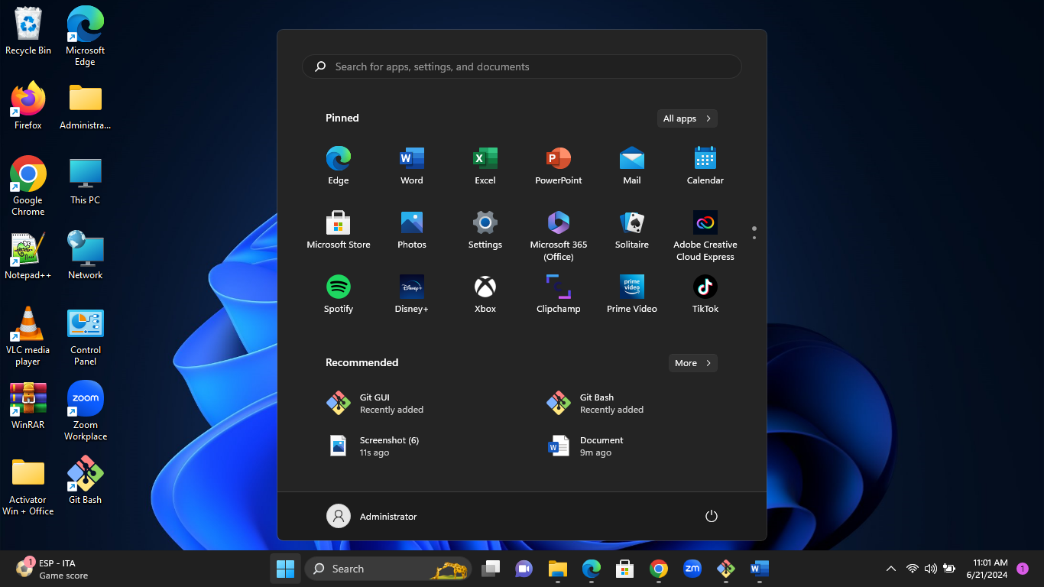

2. I downloaded and installed git on my local machine through Firefox browser. Went to my folder and opened gitbash. Then I checked the version successfully of my gitbash.

I configured git with my GitHub account with username and email. I made a directory to create a folder called Project, changed directory Project and then initialized the folder and then added the project.

I went to the Project folder and created a text document called Myproject, went back to gitbash and pushed the project as my first commit to GitHub. <https://github.com/EverlyneMmboga/Project>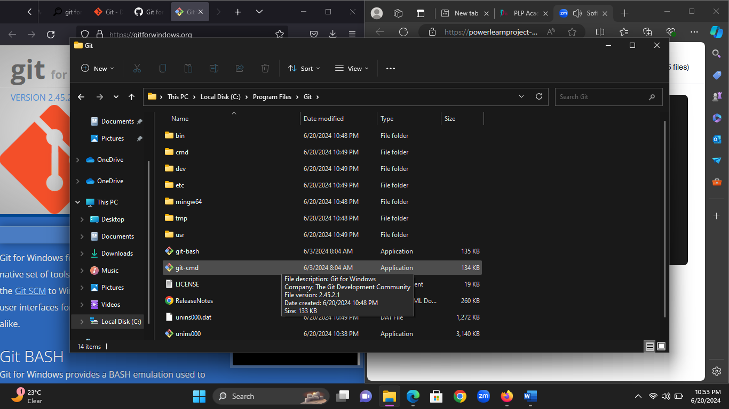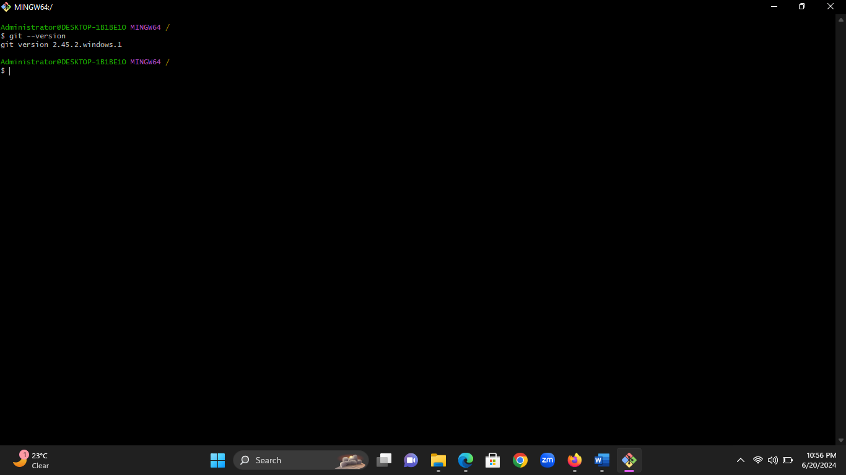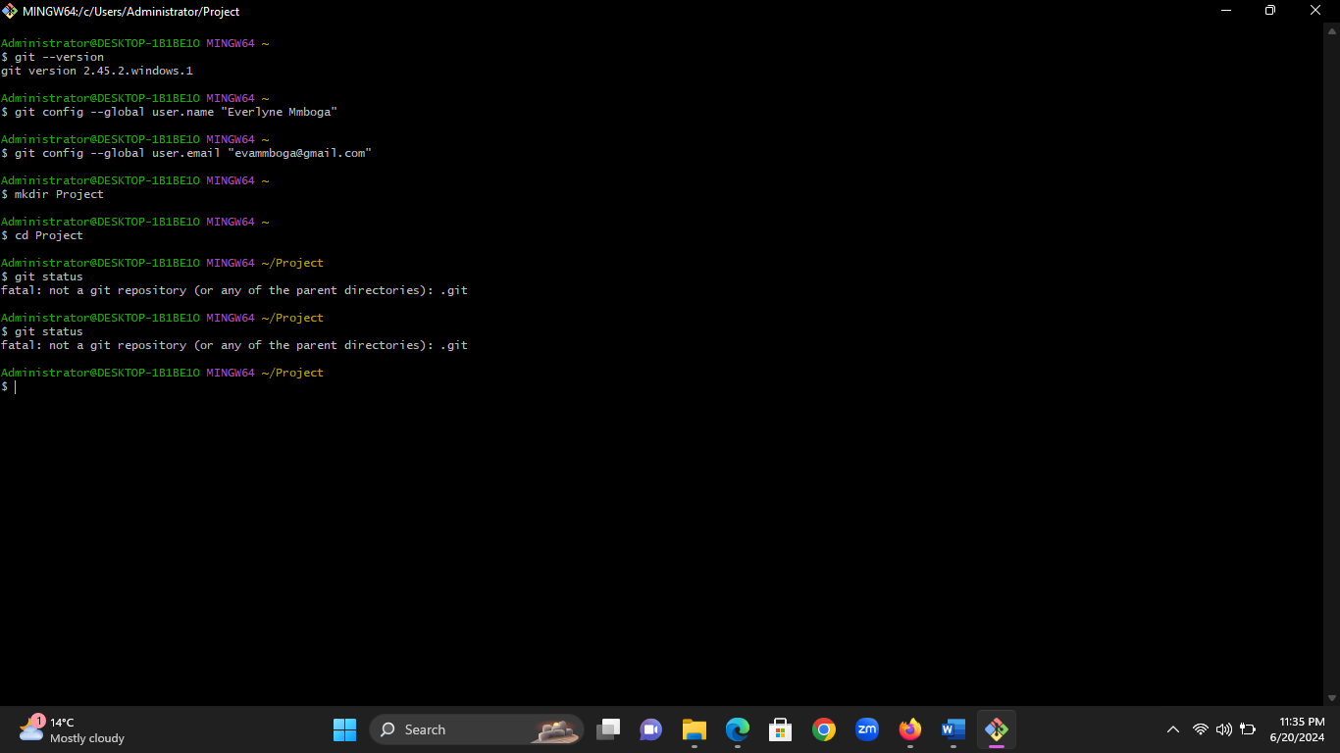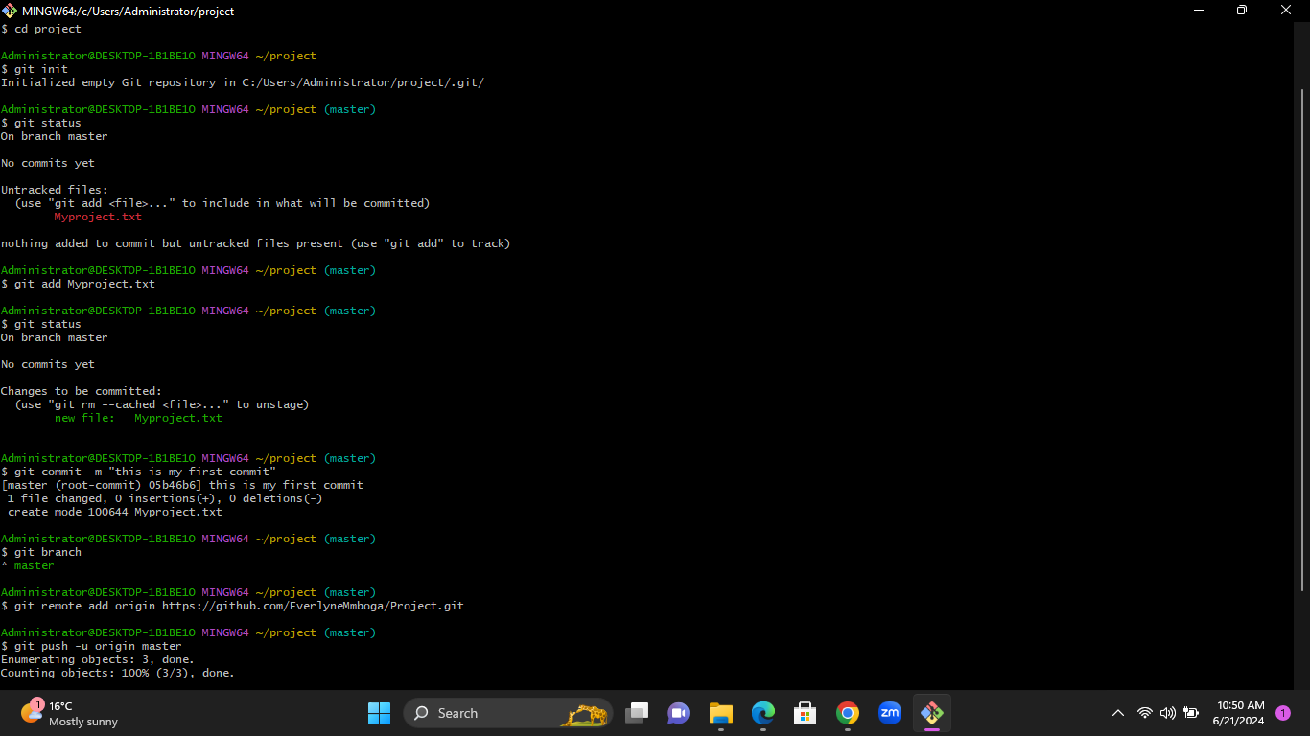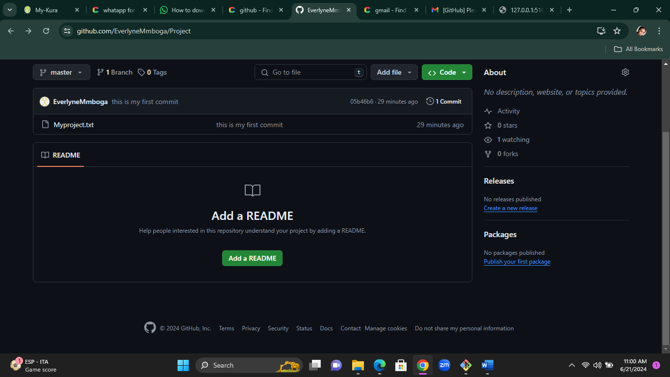

3. I downloaded and installed the visual studio code and installed it on my laptop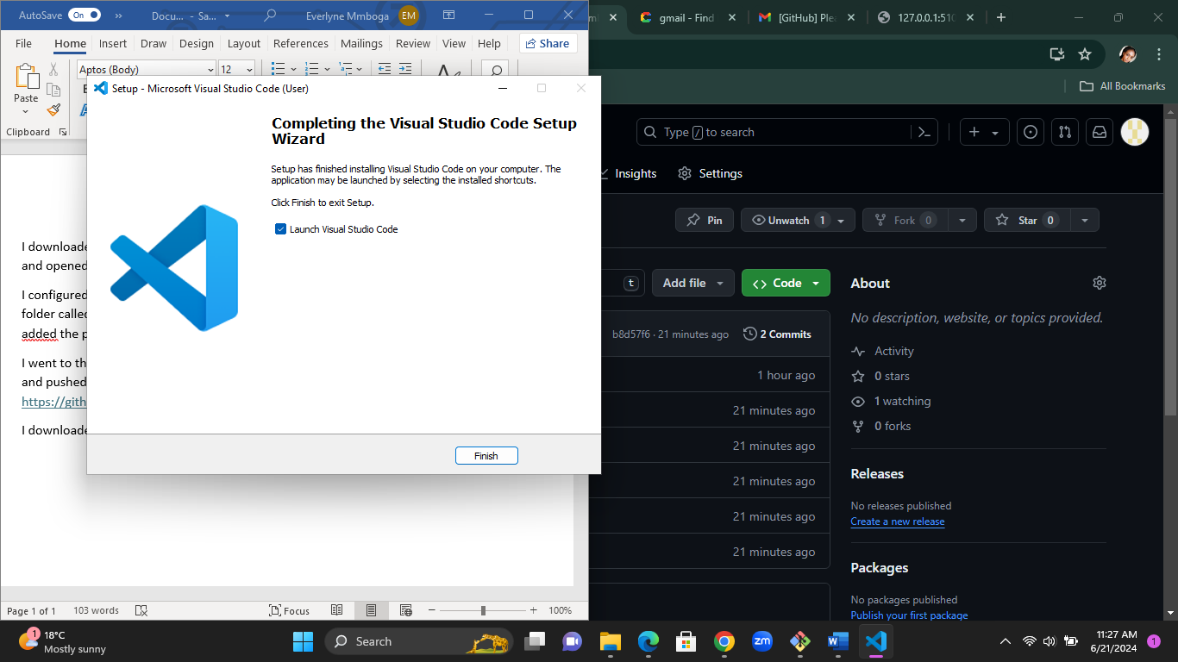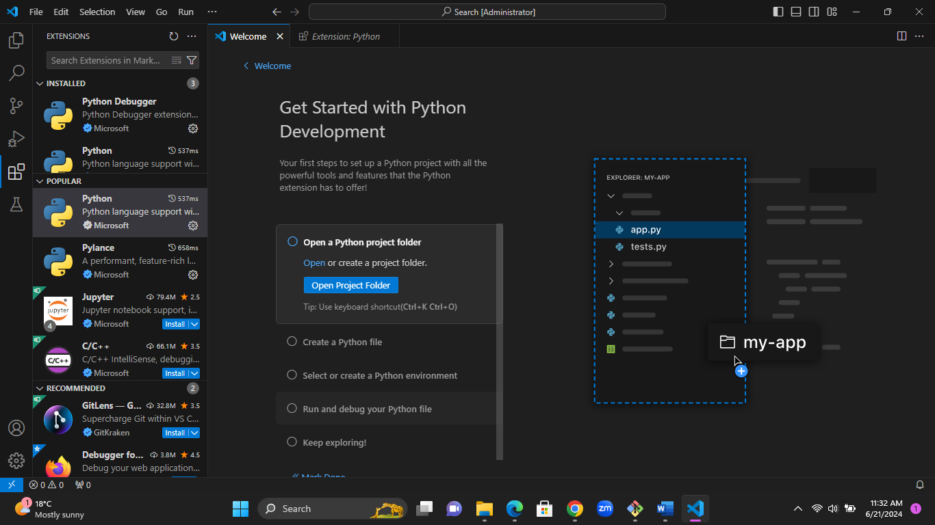

4. I downloaded and installed python on my laptop and installed it then went to command prompt to check out the python I installed. I searched for environment variables on my PC and edited python path on the user variables. Then I went ahead to check if python is installed properly on command prompt.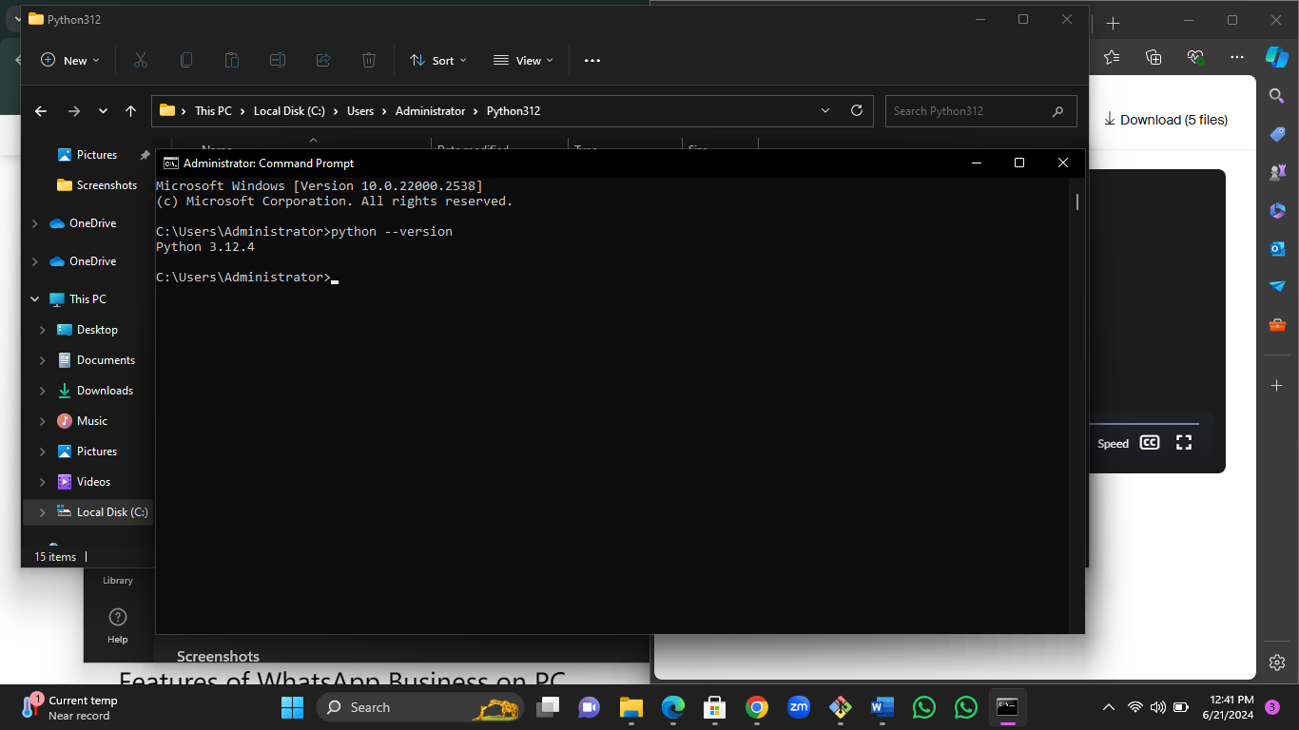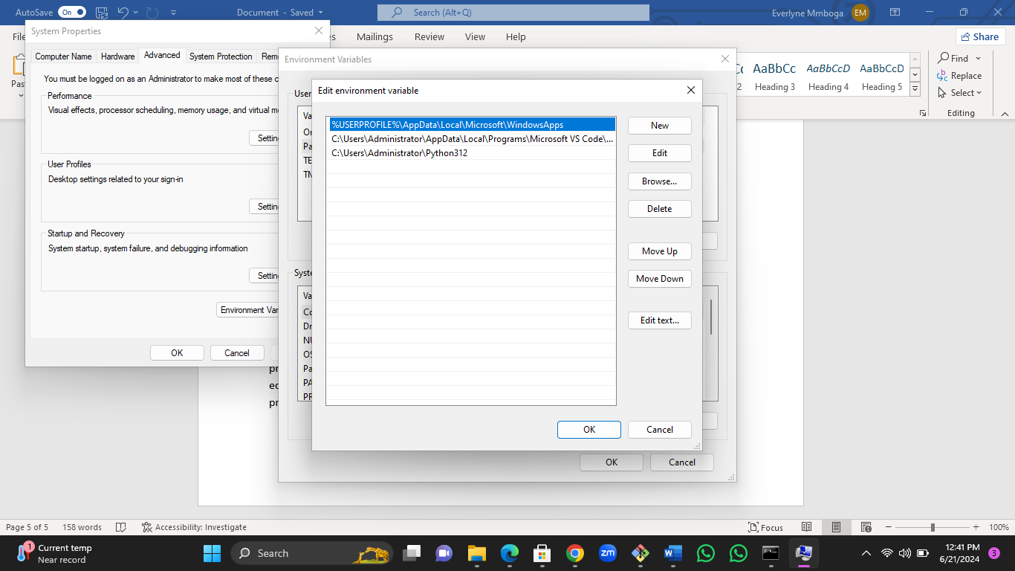

5. Downloaded and installed MySQL database and MySQL Workbench and MySQL shell in my laptop